NMH Beta-lactam Therapeutic Drug Monitoring Protocol

Clinical Protocol:
  - Infectious Diseases (ID) pharmacist to identify patients who require antibiotic TDM.
    - The patient’s primary team must also agree to monitoring.
    - An ID consult is not required.
  - Targeted patients include those with impaired organ function, altered beta-lactam PK/PD, and/or pathogens with minimum inhibitory concentration (MIC) near breakpoint. For patients with serious and/or life-threatening infections, consider the following:
    - Likeliness of having altered PK/PD (eg, immunocompromised host, demonstrated risk for augmented clearance, or requires extracorporeal organ support).
    - Likeliness of having a difficult-to-treat pathogen (eg, culture history shows pathogen with elevated MIC or multi-drug resistance).
    - Clinical response to current treatment (eg, deep-seated infection without ability to obtain adequate source control, difficult-to-penetrate site of infection).
    - Presence of known risk factors for antibiotic toxicity (eg, history of neurotoxicity, > 65 years of age with concurrent renal dysfunction, worsening mental status on antibiotic treatment)
  - Orderable Beta-Lactam serum concentrations can be ordered after at least 24 hr of continuous dosing (see Appendix A).
  - ID pharmacist to order corresponding antibiotic levels in Epic
    - The “Misc Lab Test, Referred” Lab order should be utilized for placing beta-lactam antibiotic blood samples:
      - Under ‘Name of test requested,’ manually enter the drug to be assayed.
      - Under ‘Comments,’ enter the sample collection/transport instructions for the nurse.
      - For dedicated collection, use a plain red top vacuum tube, and collect at the appropriate times.
        - Note: Red top tubes are preferred; green tops are also acceptable for most drugs per the University of Florida Health (UFHealth) Infectious Disease Pharmacokinetics Laboratory (IDPL).
      - For use of scavenged blood samples from AM labs (eg, a complete metabolic panel or basic metabolic panel which are in green tops) as a time point for PK analysis:
        - Place Misc lab order in EPIC (LAB3004 Miscellaneous order) by 1PM (1300)
        - Then call Referred Testing (61200) to alert them to the need to pull sample
        - Referred Testing will update the partially completed requisition form to reflect the collection time and date of the scavenged samples before shipping
        - Enter the sample time as the time of the BMP (eg, 04:00)
        - Sample comments can be entered via .BETALACTAMTDMLABCOMMENT
    - Use of a two-point pharmacokinetic assessment is the recommended approach for individualization and TDM:
      - Pre-dose trough (either via AM BMP or drawn 30 mins prior to next dose)
      - Post-dose peak drawn after end of infusion (refer to Appendix A).
  - The UFHealth IDPL requisition form should be completed and emailed to pathrt@nm.org
    - Complete the following fields specific to the patient and treatment: patient information, ID attending information, drug name, ICD-10 code, current dosing regimen and doses per week, date/time of last doses prior to sampling, date/time of planned times (or leave blank if scavenged blood samples used).
    - Referred testing phone: 312-926-1200
    - Referred testing fax: 312-926-6010
    - ICD-10 code:
      - Cephalosporins: T36.1X6A
      - All other systemic antibiotics: T36.8X6A
    - Circle name of the drug to be assayed in lower right-hand corner of form of the PDF form
  - Drug sample can be shipped Mon-Wed (must notify Referred Testing by 1PM on day of test). Samples are sent using standard overnight FedEx.
    - For tests sent Monday-Wednesday, expect results within 24-48 hr
    - Note: the sample may not arrive until after the morning assay run is completed
  - ID pharmacist to interpret drug levels, communicate any required dose changes to team, and document in Beta-lactam monitoring note in Epic.
    - PK/PD targets for measurable beta-lactams:
      - Levels can be interpreted using standard first order equations, the attached dosing calculator (see Appendix E), or Bayesian software (for cefepime only).
      - General recommendations for PK/PD targets for TDM (Table 1):
Table 1. Population-Based Pharmacokinetic Targets
PK/PD Index | Population | Target* | Pathogens | Drug class
fT_{>MIC} | ICU | 100% >1x to 4x MIC** | All | All
fT_{>MIC} | SOT/SCT | 100% >1x to 4x MIC | All | All
fT_{>MIC} | Floor/Ward | 100% > 1x MIC | All | All
Abbreviations: ICU, intensive care unit; MIC, minimum inhibitory concentration; SCT, stem cell transplantation; SOT, solid organ transplant
* The choice of the PK/PD target should be nuanced to the clinical status of the patient
**For seriously ill patients and those with deep seated infections or immunocompromised status consider a more aggressive goal in the context of the patient’s status

    - Interpretation of TDM results
      - Note: See Appendix E for Excel dosing calculator for first order PK and for T_{>MIC}
      - Once PK analysis is complete, T_{>MIC} can be assessed
      - If floor patient and T _{> MIC} is < 100%, increase dose or prolong infusion time to target 100% T _{> MIC}
      - If ICU patient and T _{> 1-4x MIC} is < 100%, increase dose or prolong infusion time to target 100% T _{> 1-4x MIC}
        - If trough > 8x MIC, consider reducing dose or frequency by 50%
        - If calculated/optimized beta-lactam dosing is great than that recommended in the NMH Optimizer or FDA label, consult with ID pharmacist on call (pager 55955)
        - May consider changing agent or optimizing depending on clinical scenario
    - ID pharmacist to document as a note in Epic using the dotphrase (.BLMONITORING)

Appendices:

  - Appendix A – Orderable beta-lactam antibiotics
  - APPENDIX B – UFHEALTH IDPL REQUISITION FORM
  - APPENDIX C – PHARMACOKINETIC EQUATIONS
  - APPENDIX D – EPIC NOTE TEMPLATE FORMAT
  - APPENDIX E – DOSING CALCULATOR FOR FIRST ORDER PK AND FOR T>MIC

Appendix A – Orderable beta-lactam antibioticsUFHealth IDPL Requisition form

Table 2. Orderable Beta-Lactam Antibiotics and Corresponding Desired Peak Sample Times
Antibiotic | Infusion time | Desired peak sample time
Ampicillin | 30 mins | 2 hrs post-dose
Aztreonam | 30 mins | 2 hrs post-dose
Oxacillin | 30 mins | 2 hrs post-dose
Cefazolin | 30 mins | 2 hrs post-dose
Cefepime | 30 mins | 2 hrs post-dose
Piperacillin-tazobactam | 4 hrs | 4 hrs post-dose (end of infusion)
Meropenem | 3 hrs | 3 hrs post-dose (end of infusion)

Appendix B – UFHealth IDPL Requisition form

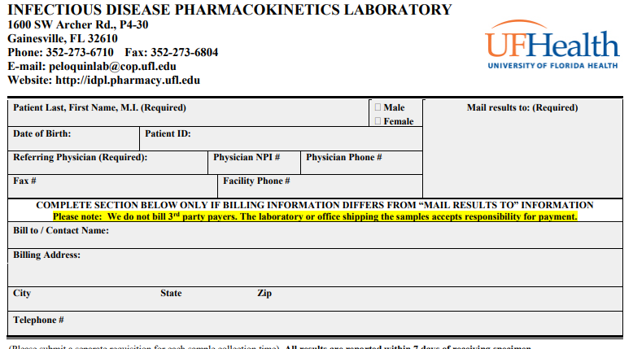

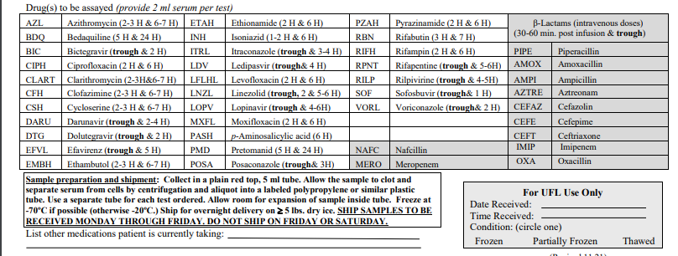

Appendix C – Pharmacokinetic Equations

Derived PK Equations:

ke = ln(C₁/C₂)
T₂-T₁
t½ = 0.693/ke
C_{max}=C₁ / e^{-ke x time (obs. – prior dose)}

C_{min}=C₁ x e^{-ke x time (next dose – obs.)}
fu= 1 – protein binding

For beta-lactams given as rapid infusions, Vd can be calculated as:

Vd = [(Dose/time_infused) / ke] x (1 – e^{-ke x time_infused}) / (C_{max} – C_{min}) (Equation 1)

For beta-lactams given as rapid infusions, fT_{>MIC} can be approximated as:

fT_{>MIC} = ln[(Dose / Vd) / MIC x fu)] x (1 / ke) x 100 / Dosing interval (Equation 2)

Appendix D – Epic note template format
Adult Cefepime Therapeutic Monitoring
(Referred send-out test to University of Florida-IDPK Lab)

Surely U ZZZTEST 26 y.o. female

Wt Readings from Last 1 Encounters:
02/21/21 | 110 kg (242 lb 8.1 oz)

Ht Readings from Last 1 Encounters:
02/21/21 | 182 cm (71.65")

ID Consult: {yes no:314532} Date of consult: 1/13/2022

Creatinine
Date | Value | Ref Range | Status
07/02/2020 | 1.25 | 0.55 - 1.30 mg/dL | Final

WBC
Date | Value | Ref Range | Status
11/18/2019 | 7.0 | 3.5 - 10.5 K/UL | Final

Other Antimicrobials:

Drug | Start Date | Stop date

Other Nephrotoxic meds:

Initial Order:

Estimated Kinetics Original Order:

Bayesian PK Analysis? {yes no:314532}

Date: | 1/12/2022 | 1/13/2022
Peak (mg/L)
Trough (mg/L)
Time Peak
Time Trough
Infusion Time (hr)
Ke (hr-1)
T 1/2 (hr)
Vd (L/kg)
Vd (L)
Extrapolated Peak (mg/L)
Extrapolated Trough (mg/L)

Relevant Microbiology:
Date
Source
Organism

Recommendation:

Assessment

Dose change necessary? {yes no:314532}

Appendix E – Excel calculator for first order PK and for T_{>MIC}

